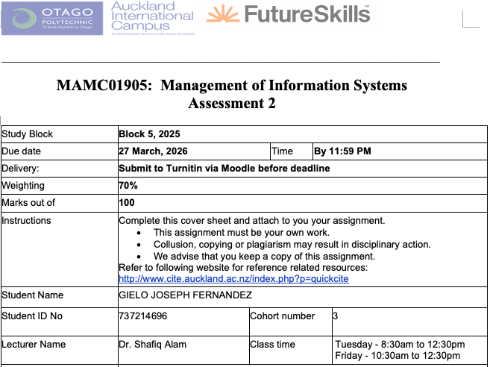
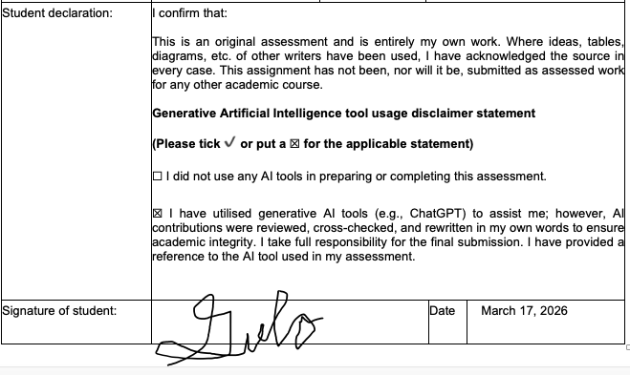
Transformation of Southern Cross Health AI Chatbot

Case Study
Southern Cross is a leading health insurance provider in New Zealand, offering services such as life, health, pet, and travel insurance (Southern Cross Healthcare). The company focuses on delivering accessible and reliable insurance solutions to its members.
Currently, Southern Cross uses Aimee, an AI chatbot that answers customer questions about the health system and insurance terms (McGregor, 2019). While helpful for general inquiries, Aimee’s capabilities are limited and do not provide personalized guidance.
In the future, Aimee could be enhanced to assist with claims, estimate coverage in real time, and offer tailored plan suggestions based on individual profiles and health history. This would transform her into a proactive digital assistant, improving the overall member experience.
To achieve this, Southern Cross will develop and train advanced AI models, integrate comprehensive data governance and security measures (MinterEllison New Zealand, 2025), and adopt Agile methods for continuous improvement..

1.Introduction
In today’s age, chatbots plays a huge part in the success of organizations, not just insurance organizations. Chatbots, also referred to as conversational agents, are interactive intelligent systems that utilize Natural Language Processing (NLP) and machine learning to conduct text or voice-based conversations with humans (Rodríguez Cardona et al., 2021).
In the insurance industry, chatbots are vital for driving digital transformation and helping traditional companies remain competitive against emerging Insurance tech startups (Subhashini et al., 2025). They provide critical 24/7 availability, allowing policyholders to receive immediate clarifications on policy features, premium payments, and claim procedures (Ezhilarasi, 2025).
Southern Cross, New Zealand’s leader in providing health insurance. Southern Cross currently has different cashflow or services such as life insurance, health insurance, pet insurance, and travel insurance(Southern Cross). For Southern Cross, the transformation of the ai chatbot will drive operational efficiency, enhance customer engagement, and provide a strategic competitive advantage in a market increasingly disrupted by Insurance Tech startups (Rodríguez Cardona et al., 2019).
This report will analyse the transformation of AI Chatbot for Southern Cross. Part two will discuss the evolution of AI Chatbot, and the present policies and management regarding the AI Chatbot in Southern Cross. Part three will discuss the current trends and future development of AI Chatbot. Part four will discuss the recommendations and will conclude with the summary in part five.
2. Evolution of Chatbot System at Southern Cross Health
A number of changes have happened in how Southern Cross Healthcare has been manging the policies and the procedures related to their AI chatbot system. Below, we talk about their current state of the art in terms of Managerial policies and procedures.
2.1 Present Management Procedures
Like Southern Cross, insurance companies implement rigorous management procedures to ensure AI chatbots are secure, effective, and compliant with strict financial regulations. These procedures range from long-term strategic planning, continuous technical monitoring, and data security management.
Regarding Long-term Strategic planning, it includes the following:
- Developing a clear AI strategy that corresponds to its specific prerequisites and organizational goals (Haglund, 2024). Management create coherent plans for AI exploration, adoption, and innovation to align technology with long-term business goal (Alkhelb & Alshagrawi, 2025). Management also define the specific customer needs and establish measurable performance goals before full-scale rollouts (Wöger, 2024).
- Instead of a full-scale rollout, management procedures follow a phased strategy to build confidence and minimize risk. This involves starting with small-scale pilot projects in non-critical areas to build organizational confidence before expanding to complex use cases like automated underwriting (Wöger, 2024).
- Planning includes employee upskilling to transition staff from routine insurance processors to become expert in AI. It also ensure seamless handoffs, where a human agent receives the full contextual conversation history if the bot cannot resolve a query (Edgar et al., 2025).
Regarding Continuous Technical Monitoring, it includes the following:
- Functional Testing where the management validates intent and entity recognition to ensure the bot accurately extracts details like policy numbers or beneficiary names. One example is dialogue flow testing to confirm the bot handles topic changing, such as a user changing from a claim query to a policy question mid-conversation, without losing coherence (Pareek, 2024).
- AI specific testing where management mandates testing for Natural Language Processing(NLP) accuracy and implements bias and fairness testing to ensure neutral and equitable responses across demographics (Subhashini et al., 2025).
Regarding Data and Security Management, it includes the following:
- Compliance and Security testing where managers adopt Security by Design, where security is a top priority from the beginning of software development rather than an afterthought (Bokolo & Daramola, 2024). One part of it is applying STRIDE model to identify six categories of threats: Spoofing, Tampering, Repudiation, Information Disclosure, Denial of Service, and Elevation of Privilege (Bokolo & Daramola, 2024).
2.2 Present Management Policies
As the contemporary policies, the current policies relate to the above procedures are outlined here:
- In regards to Developing a clear AI strategy, managers should prioritize tier 1 tasks, routine, high-volume inquiries like policy FAQs, claim status updates, and renewal reminders (Edgar et al., 2025). One example is AXA, where they developed "Data for Good" strategy that aligns AI initiatives with corporate social responsibility (Tase, 2024).
- In regards to Phased Strategy, companies implement guidelines for safe exploration of generative AI. One example is Gjensidige, a Norwegian Insurance Company, opted not to restrict access to tools like ChatGPT but instead provided employees with specific usage guidelines to mitigate risks such as data leaks (Haglund, 2024). Another example is the insurance company Liberty Mutual, where they initiated a chatbot pilot for simple queries that successfully reduced call centre volume (Tase, 2024).
- In regards to Employee Upskilling, roles are redesigned to reallocate human resources away from repetitive tasks and into high-value functions requiring empathy and complex judgment, such as sensitive claims related to death or disability (Edgar et al., 2025). One example is the company Zurich Insurance where they implemented a company-wide "Data Science Academy" to increase data literacy among all employee levels (Tase, 2024).
- In regards Functional Testing, policies require "Human-in-the-loop" systems where a chatbot must automatically detect when it cannot resolve a query and seamlessly transfer the full conversation history to a human agent (Pareek, 2024). Also, regulations like the EU AI Act, management policies mandate that the bot must clearly disclose its identity at the start of an interaction so users know they are not speaking to a human (Pirilä et al., 2022). For Southern Cross, during the development of the chatbot, before any update to Aimee’s conversational engine is pushed to the live environment, management follows a rigorous training protocol (The Spinoff, 2019).
- In regards to Compliance and Security Testing, policies include ensuring that AI chatbot has security features such as end-to-end encryption for transmitted data (Bokolo & Daramola, 2024), role-based access to ensure users only interact with data relevant to their department (Bokolo & Daramola, 2024), log files for auditing and traceability, which is critical for meeting regulatory disclosure requirements (Pareek, 2024).
- In regards to AI Specific Testing, policies include mandates that all AI models must undergo regular audits for bias and accuracy to prevent model degradation over time (Pareek, 2024). Policies also include that AI driven decisions, particularly those affecting claims or premiums, must be accompanied by a human-readable rationale that can be audited by regulators or explained to customers (Tase, 2024).
2.1 Present management policies and procedures ( 700 words)
The management procedures, as part of ERP security management, managers implement Role-Based Access Control (RBAC) by assigning users permissions strictly according to their job responsibilities, and enforce Multi-Factor Authentication (MFA) to ensure that all system access requires additional verification, thereby protecting sensitive data.

As the contemporary policies, the curent policies relate to the above two procedures are outlined here..
Example Access Control Policy (Retail Industry Style)
"All employees must be assigned access to the ERP system strictly according to their role. Access beyond the role must be requested through the formal approval workflow and is subject to quarterly review. User accounts are deactivated immediately upon termination or role change to prevent unauthorized access."
— Adapted from best practices outlined in SANS Institute ERP Security Guidance
Example Multi-Factor Authentication Policy (Retail Industry Style)
"All system users are required to authenticate using a password plus a secondary verification method such as a one-time passcode or hardware token. Accounts will be locked after five consecutive failed login attempts, and managers must review failed access attempts monthly to ensure compliance."
— Adapted from publicly available ERP security recommendations for retail and large organizations (ISACA, ERP Security Controls)

i. Management Procedures (how it works- what are the steps. Not steps of usage but of management- Think yourself to be the manager of the systems- don’t talk about how user use the systems… talk about how the systems is managed, how the systems are updated, how the systems are retired. the processes… … Need to talk about management activities rather than usage activities.)

ii. Management Policies (rules)- for example who (who decides what contents (movies) should be added. Who ads it, who updates the system.) what are the rules for security policies, privacy policies etc.

3. Current Trends and Future Developments
There are a number technology taht is up for adoption in term ERP in the domain of hardware, software, network, and data. Some of such technology is analysed below that well suit the needs of TWS.
3.1 Current Trends in information system

3.1 future developments in information system

3. 3 Transition TWS from current to goal state
Talk about the framwork of transition. ... TOGAF and zachman.
• - from mission and vision of TWG
• Their current state in one sentence from the prvious section and based on the Merly’s maturity model, since the TWG is level 2 mosly, it need to transition to level 3.
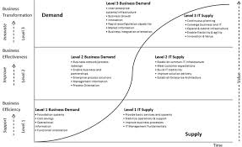

• Their goal state form the section above -> level 3. on the merlyns maturity model
• The framework of how to change / transition
Lorem ipsum
4. Recommendations
Lorem ipsum
5. Summary and Conclusion
Lorem ipsum
6. References
Alkhelb, A. A., & Alshagrawi, S. (2025). Role of artificial intelligence in healthcare insurance: Systematic literature review. Exploration of Digital Health Technologies, 3. https://doi.org/10.37349/edht.2025.101145
Bokolo, Z., & Daramola, O. (2024). Elicitation of security threats and vulnerabilities in Insurance chatbots using STRIDE. Scientific Reports, 14(1). https://doi.org/10.1038/s41598-024-68791-z
Edgar, T., Fletcher, N., & Lane, V. (2025). The Transformative Benefits and Implementation Challenges of Conversational Artificial Intelligence Chatbots in Enhancing Efficiency and Customer Experience within Modern Insurance Operations.
Ezhilarasi, A. (2025). AI chatbot interactions and customer satisfaction in the insurance sector: Evidence from Star Health & Allied Insurance Company Limited in Chennai.
Haglund, S. (2024). Identifying barriers to increased AI in the insurance industry: A case study [Master’s thesis, KTH Royal Institute of Technology]. http://www.diva-portal.org/smash/record.jsf?pid=diva2:1897535
McGregor, A. (2019, November 21). Human touch meets AI on health insurance frontline. Southern Cross NZ. https://www.southerncross.co.nz/news/2019/health-insurance-ai-digital-human
MinterEllison New Zealand. (2025, November 10). AI risks: What do insurers want to know about your use of AI? MinterEllison NZ Insights. https://www.minterellison.co.nz/insights/ai-risks-what-do-insurers-want-to-know-about-your
Pareek, C. S. (2024). Beyond Automation: A Rigorous Testing Framework for Reliable AI Chatbots in Life Insurance. International Journal of Science and Research (IJSR), 13(6), 1485–1493.
Pirilä, T., Salminen, J., Osburg, V.-S., Yoganathan, V., & Jansen, B. J. (2022). Investigating the Role of Technical and Process Quality in Chatbots: A Case Study from the Insurance Industry. 1485–1494. https://hdl.handle.net
Rodríguez Cardona, D., Janssen, A., Guhr, N., Breitner, M. H., & Milde, J. (2021). A matter of trust? Examination of chatbot usage in insurance business.
Rodríguez Cardona, D., Werth, O., Schönborn, S., & Breitner, M. H. (2019). A mixed methods analysis of the adoption and diffusion of chatbot technology in the German insurance sector.
Southern Cross. About Southern Cross. https://www.southerncross.co.nz/about-southern-cross
Subhashini, V., Anusha, T., Swathi, M., & Sridhar, K. (2025). AI powered chatbot in health insurance.
Tase, J. (2024). Generative AI in Insurance Industries: Transforming Workflows and Enhancing Customer Experience. International Research Journal of Engineering Science Technology and Innovation, 11(7), 512–519.
Wöger, M. (2024). The future of customer service chatbots in the Austrian finance and insurance industry: An analysis of expert’s and generation z’s perspectives on addressing the limitations of chatbots. FH Joanneum.

